Health Screening and Promotion Center
AMC Health Screening and Promotion Center has opened in 1990 and moved to East Building in 1996 and to a large pleasant area with the beautiful views of Hangang River on the 4F of New Building in 2008 (6,612㎡, 71,171 sqft). More than 40,000 people receive health screening a year and the early diagnosis rate of cancers such as thyroid cancer, gastric cancer, colorectal cancer, prostate cancer, breast cancer, and lung cancer is about 0.1%, which represents the center’s excellence in the size and accuracy.
We offer a wide range of packages customized by gender, age, and disease by developing diverse programs that considered individuals’ health conditions. Also according to individual schedules, you can receive a variety of thorough examinations in a day, stay in hotel-style patient room, and enjoy premium care services in a pleasant comfortable environment. AMC’s systematic program of health questionnaire is able to identify your medical history and current symptoms. Based on it, we scientifically analyze the results and your lifestyle to provide medical guidelines for health care even after physical examination.

STANDARD PROGRAM
Hour Required : 3 hours
Fees : Male 1,800,000 KRW (Approx. USD 1,670) / Female 1,900,000 KRW (Approx. USD 1,765)
Managing your health while you are healthy is paramount.
Diseases like diabetes, hypertension, heart disease and cancer can threaten your precious health without warning.
Screening for signs of health threats and early diagnosis of disease is the first step to a healthy and long life.
Examination Items
Head & Neck Exam (Male) | Carotid Ultrasonography
Thyroid Exam | Thyroid Ultrasonography
Pulmonologic Exam | Pulmonary function test
 | Chest X-ray
Cardiovascular Exam | Blood pressure
 | Electrocardiography
Breast Exam (Female) | Mammography
 | Breast Ultrasonography
Stomarch Exam | Esophagogastroduodenoscopy under conscious sedation
Gastroeterologic Exam | Abdomen Ultrasonography
Urologic Exam (Male) | Prostate Ultrasonography
 | Digital Rectal Exam
Gynecologic Exam  (Female) | Pelvic Exam
 | Pap smear
 | Pelvic Ultrasonography
 | HPV (Human Papilloma Virus)
Osteoporosis Exam | Bone densitometry
 | T-L spine X-ray
Body Measurement | Height, Weight, Ideal Weight, Body Mass Index, Body Fat
Ophthalmic Exam | Visual Acuity, Tonometry, Fundus Photography
Audiometry Test | Audiometry
Dental Exam | Dental Exam
Blood Test | Complete Blood Count, Anemia, Blood Coagulation, Blood type, Liver function
 | Kidney function, Thyroid function, Lipid, Diabetes, Insulin, Uric Acid
 | Hepatitis A/B/C, Syphilis, AIDS, H.Pylori
 | Female hormone, Male hormone
Boold Tumor Market | α-FP (Liver)
 | CEA (Colon, Lung)
 | CA19-9 (Pancreas, Biliary Tract)
 | CA125 (Uterus, Ovary)
 | PSA (Prostate)
Urine Exam | Urinalysis
Stool Exam | Occult blood, Protozoa, Parasite

SPECIALIZED CANCER PROGRAM
Hour Required : 5 hours
Fees : Male 2,500,000 KRW (Approx. USD 2,320) / Female 2,600,000 KRW (Approx. USD 2,410)

Specialized check-up program for detection of specific organ cancer
- Stomach Cancer
- Colon Cancer
- Pelvic Cancer
- Breast Cancer
- Lung Cancer
- Liver Cancer
- Prostate Cancer
- Thyroid Cancer
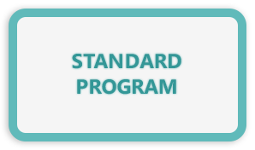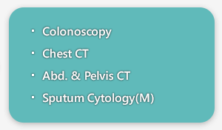
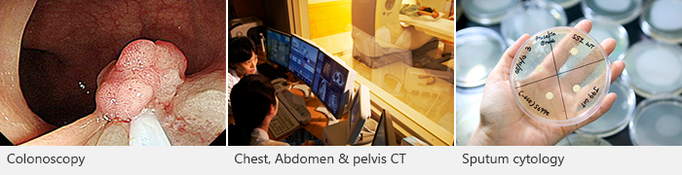

Colonoscopy
Examination of the inside of the entire large intestine, from the rectum through the orifice of the appendix, by inserting an endoscope into the anus

Chest CT
Examination of the organs and structures in your chest area, e.g., lungs, trachea and bronchi, esophagus, mediastinum, and pulmonary arteries and veins

Abdomen & Pelvis CT
A test using x-ray equipment with computers to produce detailed cross-sectional images of the abdomen/pelvis. This test is particularly useful in examining some parts of the organs and retroperitoneal structures

SPECIALIZED HEART PROGRAM
Hour Required : 5 hours
Fees : Male 2,650,000 KRW (Approx. USD 2,460) / Female 3,050,000 KRW (Approx. USD 2,830)

Specialized check-up program for detection of cardiovascular disease
(Colonoscopy not included)
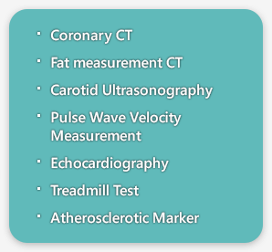
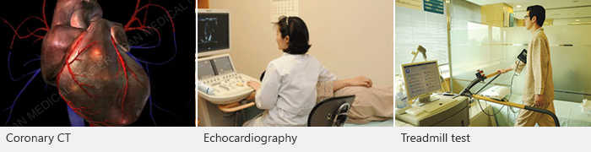

Coronary CT
Cardiac coronary angiogram images obtained with rapid CT scanning and 3D reconstruction

Fat measurement CT
Calculating abdomen fat, subcutaneous fat, intraperitoneal fat areas with CT

Carotid Ultrasonography
To reveal atherosclerosis in the carotid arteries using ultrasound

Echocardiography
Evaluating heart structure and function with ultrasongraphy

Treadmill test
To evaluate ischemic heart disease with exercise on a treadmill

DELUXE PROGRAM
Hour Required : 6 hours
Fees : Male 3,450,000 KRW (Approx. USD 3,200) / Female 3,900,000 KRW (Approx. USD 3,610)

Detailed check-up program including both specialized cancer and
heart program
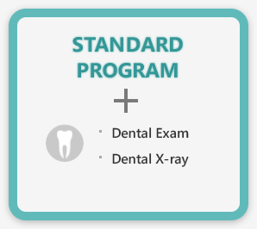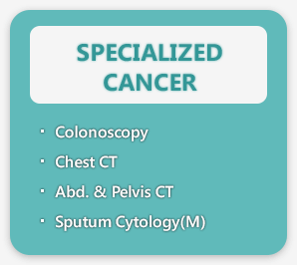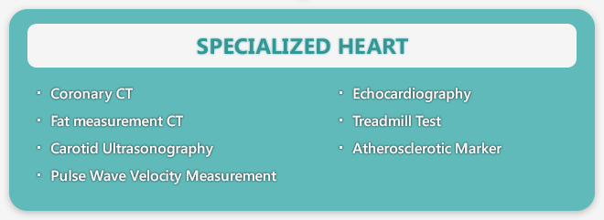

Colonoscopy
Examination of the inside of the entire large intestine, from the rectum through the orifice of the appendix, by inserting an endoscope into the anus

Chest CT
Examination of the organs and structures in your chest area, e.g., lungs, trachea and bronchi, esophagus, mediastinum, and pulmonary arteries and veins

Abdomen & Pelvis CT
A test using x-ray equipment with computers to produce detailed cross-sectional images of the abdomen/pelvis. This test is particularly useful in examining some parts of the organs and retroperitoneal structures

Sputum Cytology
Sputum is treated with a special stain, examined by microscope.

Coronary CT
Cardiac coronary angiogram images obtained with rapid CT scanning and 3D reconstruction

Fat measurement CT
Calculating abdomen fat, subcutaneous fat, intraperitoneal fat areas with CT

Carotid Ultrasonography
To reveal atherosclerosis in the carotid arteries using ultrasound

Echocardiography
Evaluating heart structure and function with ultrasongraphy

Treadmill test
To evaluate ischemic heart disease with exercise on a treadmill

PLATINUM PROGRAM
Hour Required : 7 hours
Fees : Male 6,000,000 KRW (Approx. USD 5,550) / Female 6,500,000 KRW (Approx. USD 6,010)

Extensive and detailed check-up program including cancer,
heart and brain (Escorted by a special nurse)
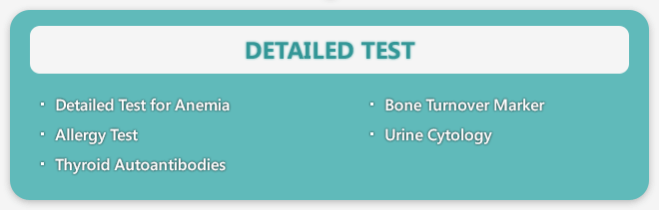

Standard Program + Dental X-ray

Brain MRI & MR Angiography
Test that uses a magnetic field, radio waves and a computer to create clear images of the brain. The brain MRI can show brain parenchymal disease. The MR angiogram (MRA) can be performed to identify vascular problems

Colonoscopy
Examination of the inside of the entire large intestine, from the rectum through the orifice of the appendix, by inserting an endoscope into the anus

Chest CT
Examination of the organs and structures in your chest area, e.g., lungs, trachea and bronchi, esophagus, mediastinum, and pulmonary arteries and veins

Abdomen & Pelvis CT
A test using x-ray equipment with computers to produce detailed cross-sectional images of the abdomen/pelvis. This test is particularly useful in examining some parts of the organs and retroperitoneal structures

Sputum Cytology
Sputum is treated with a special stain, examined by microscope.

Coronary CT
Cardiac coronary angiogram images obtained with rapid CT scanning and 3D reconstruction

Fat measurement CT
Calculating abdomen fat, subcutaneous fat, intraperitoneal fat areas with CT

Carotid Ultrasonography
To reveal atherosclerosis in the carotid arteries using ultrasound

Echocardiography
Evaluating heart structure and function with ultrasongraphy

Treadmill test
To evaluate ischemic heart disease with exercise on a treadmill

PREMIUM PROGRAM
Fees : 2 days / 1 night 8,000,000 KRW (Approx. USD 7,400)
3 days / 2 nights 10,000,000 KRW (Approx. USD 9,240)
Our Premium Program is specially designed to focus on the early detection anc prevention of previously undiscovered conditions such as cerebrovascular and cardiovascular diseases as well as various cancers through the utilization of the lastest medical equipment and the extensive experience of our Health Screening and Promotion Center’s doctors.
Examination Items
PET-CT | Whole Body PET
Head & Neck Exam | Brain MRI & MRA, Carotid Ultrasonography
Thyroid Exam | Thyroid Ultrasonography
Pulmonologic Exam | Pulmonary function test
 | Chest CT, Chest X-ray
Cardiovascular Exam | Blood pressure, Pulse wave velocity measurement
 | Electrocardiography, Treadmill Test
 | Echocardiography
 | Coronary CT
Breast Exam (Female) | Mammography, Breast Ultrasonography
Stomarch Exam | Esophagogastroduodenoscopy under conscious sedation
Large Intesting Exam | Colonoscopy under conscious sedation
Gastroeterologic Exam | Abdomen Ultrasonography
 | Abdomen & Pelvis CT, Fat measurement CT
Urologic Exam (Male) | Prostate Ultrasonography, Digital Rectal Exam
Gynecologic Exam  (Female) | Pelvic Exam
 | Pelvic Ultrasonography
 | Pap smear, HPV (Human Papilloma Virus)
Osteoporosis Exam | Bone densitometry, T-L spine X-ray
Body Measurement | Height, Weight, Ideal Weight, Body Mass Index, Body Fat
Ophthalmic Exam | Visual Acuity, Tonometry, Fundus Photography
Audiometry Test | Audiometry
Dental Exam | Dental Exam, Dental X-ray
Blood Test | Complete Blood Count, Anemia, Blood Coagulation, Blood type, Liver function
 | Kidney function, Thyroid function, Lipid, Diabetes, Insulin, Uric Acid
 | Hepatitis A/B/C, Syphilis, AIDS, H.Pylori
 | Female Hormone, Male Hormone
Boold Tumor Market | α-FP (Liver), CEA (Colon, Lung), CA19-9 (Pancreas, Biliary Tract)
 | CA125 (Uterus, Ovary), PSA (Prostate)
Specialized Blood Test | Atherosclerotic market
 | Detailed test for anemia
 | Allergy Test
 | Thyroid Autoantibodies
 | Bone turnover marker
Urine Exam | Urinalysis, Urine Cytology, Albumin/Creatinine ratio
Stool Exam | Occult blood, Protozoa, Parasite
Sputum Exam | Sputum Cytology

